DFSA Cyber Risk Framework Compliance for Log360
Tagline: Meet the DFSA's cyber risk management expectations with security monitoring from Log360.

Overview
The DFSA Cyber Risk Framework Compliance extension for Log360 supports DIFC-licensed financial services firms in fulfilling the cybersecurity risk management, threat detection, and incident response obligations required by the Dubai Financial Services Authority.
Log360 collects and correlates logs from financial applications, trading systems, cloud environments, and network infrastructure, providing real-time visibility into cyber risk indicators. Compliance and security teams can monitor critical controls, identify incidents early, and deliver audit-grade evidence to DFSA supervisors demonstrating the maturity of their cyber risk management programs.

Key Features
- Generate audit-ready reports covering DFSA cyber risk framework requirements including access control monitoring, threat detection, and incident logging.
- Track privileged user actions, administrative changes, and access events across financial services systems in real time.
- Identify threats targeting DIFC financial institutions through behavioral analytics and anomaly detection, with specialized rules for fraud detection and account compromise across trading systems.
- Export compliance reports in PDF and CSV formats for DFSA supervisory submissions and internal cyber risk committee reviews.
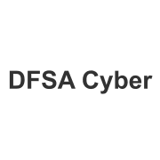
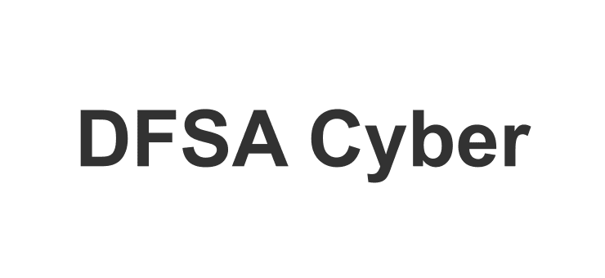

Screenshots
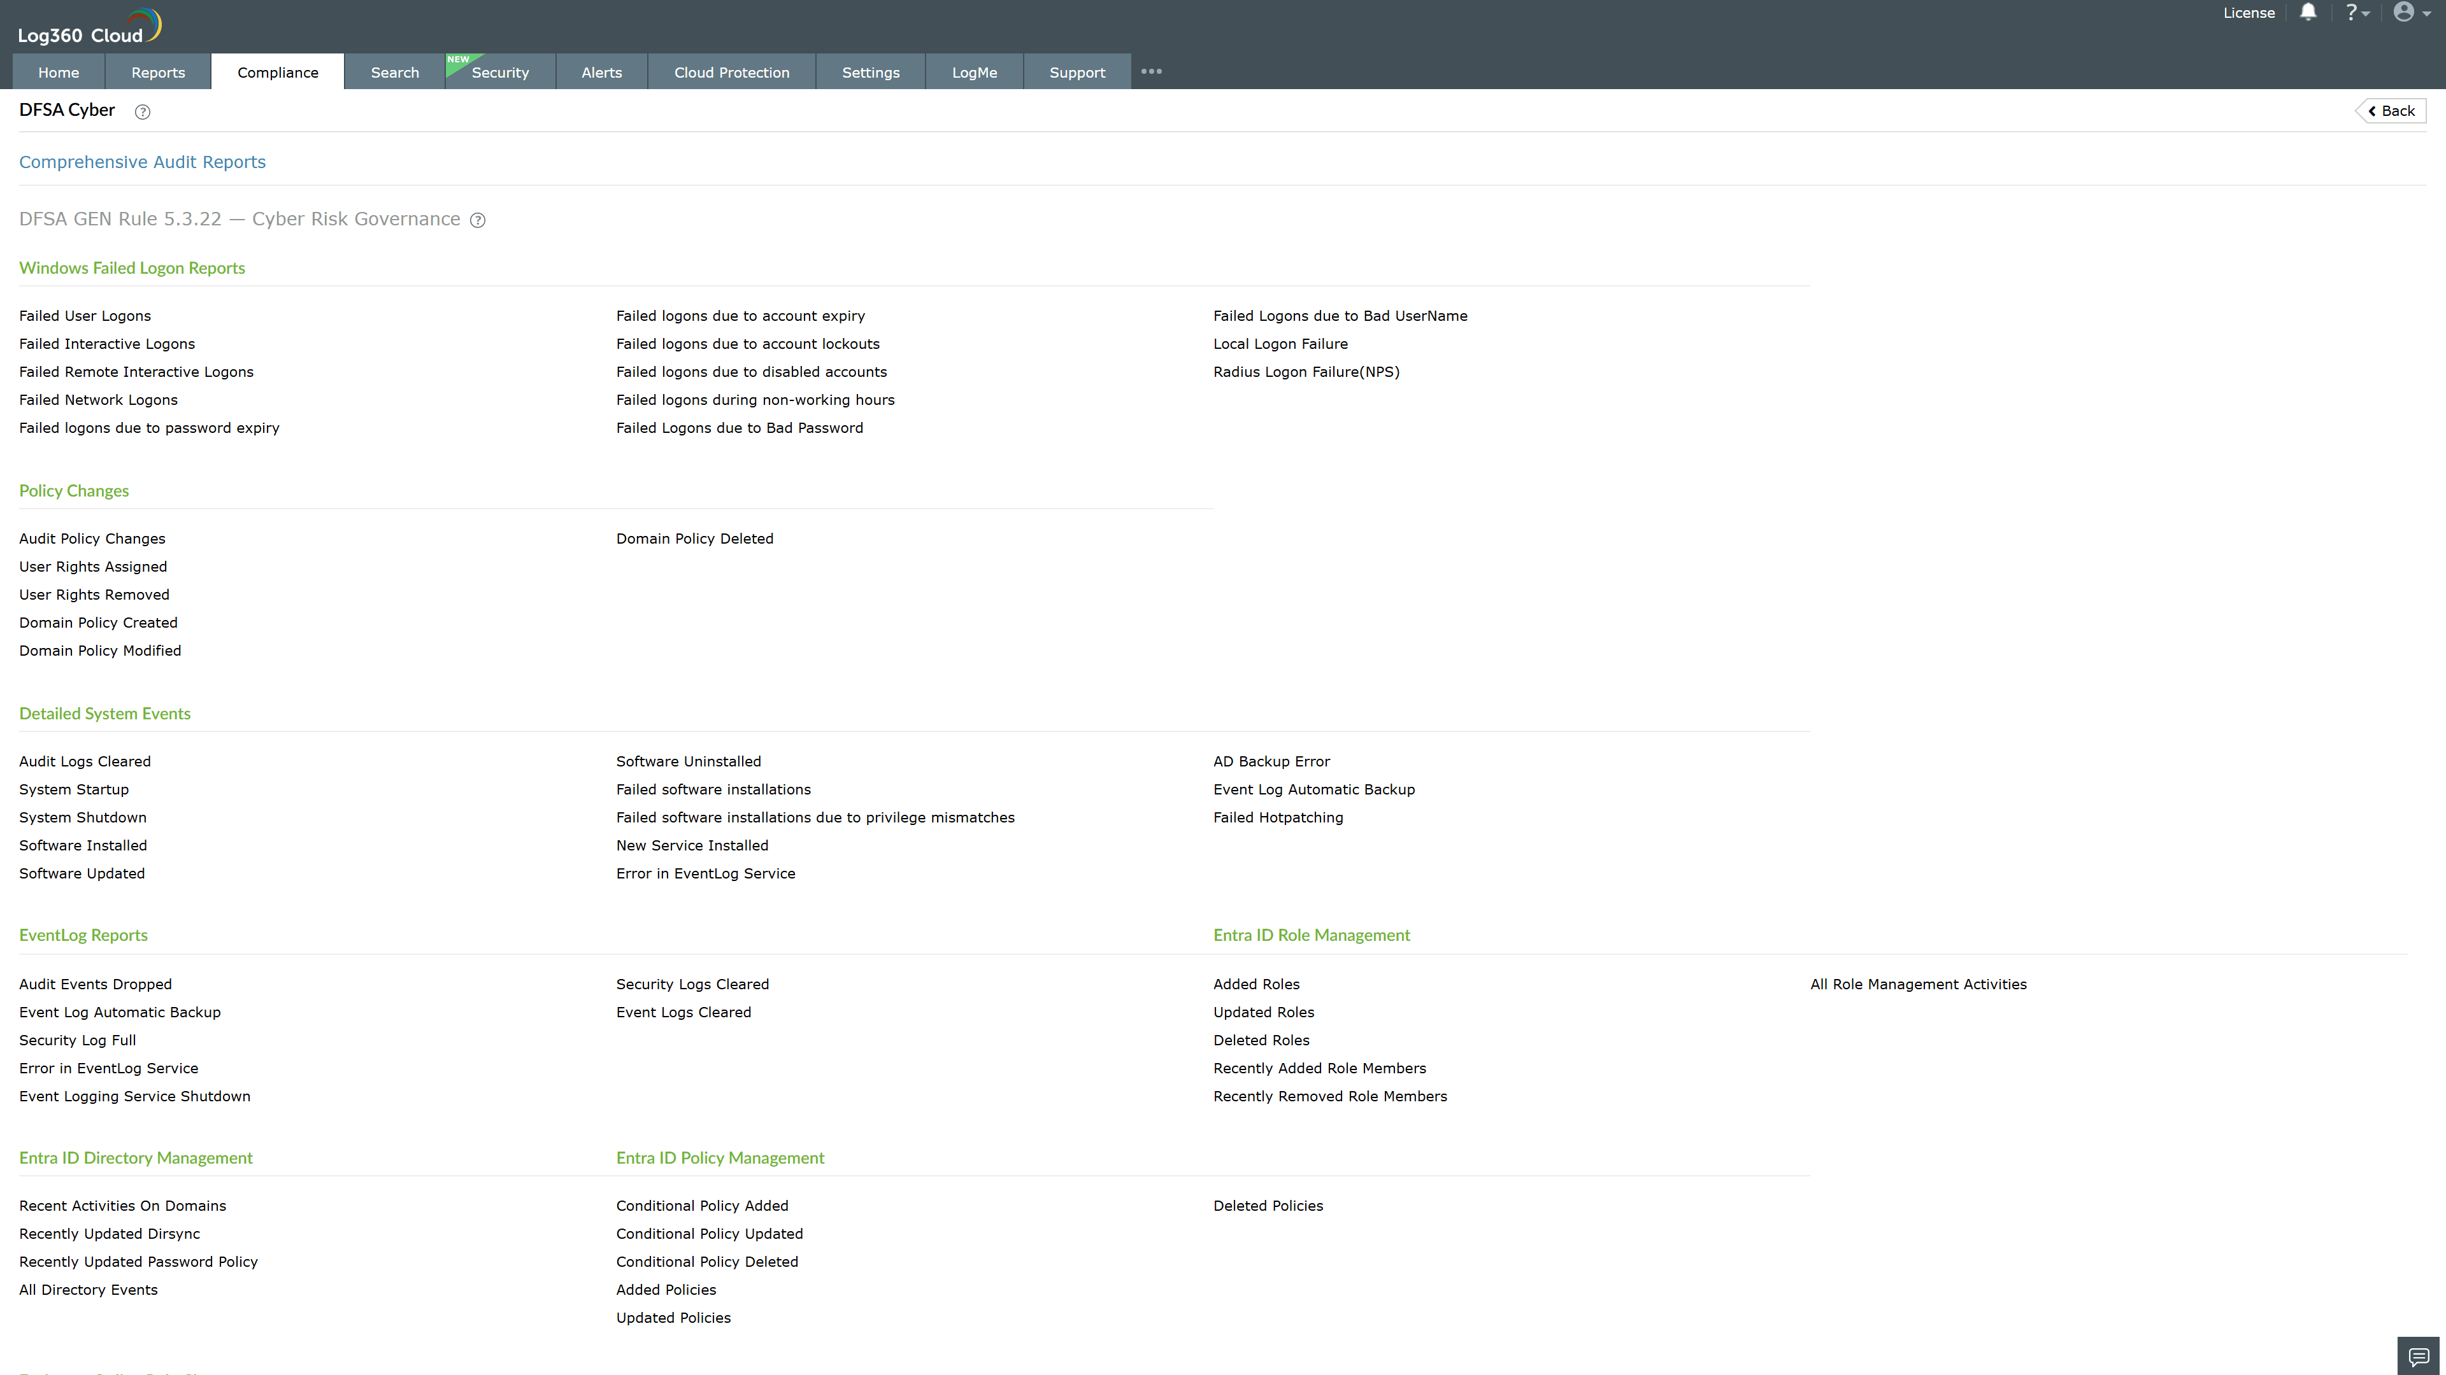
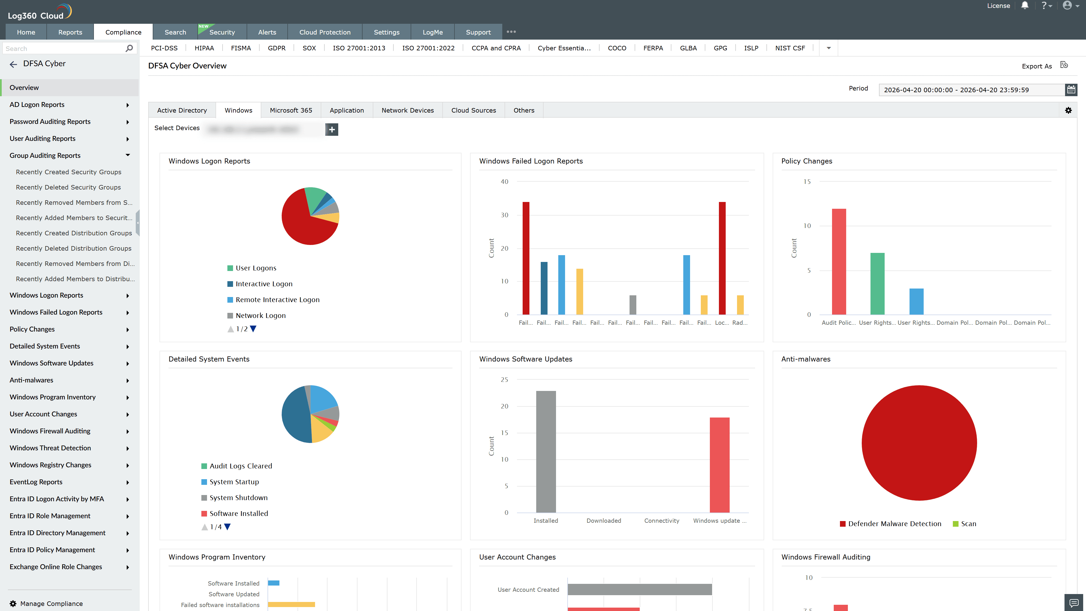
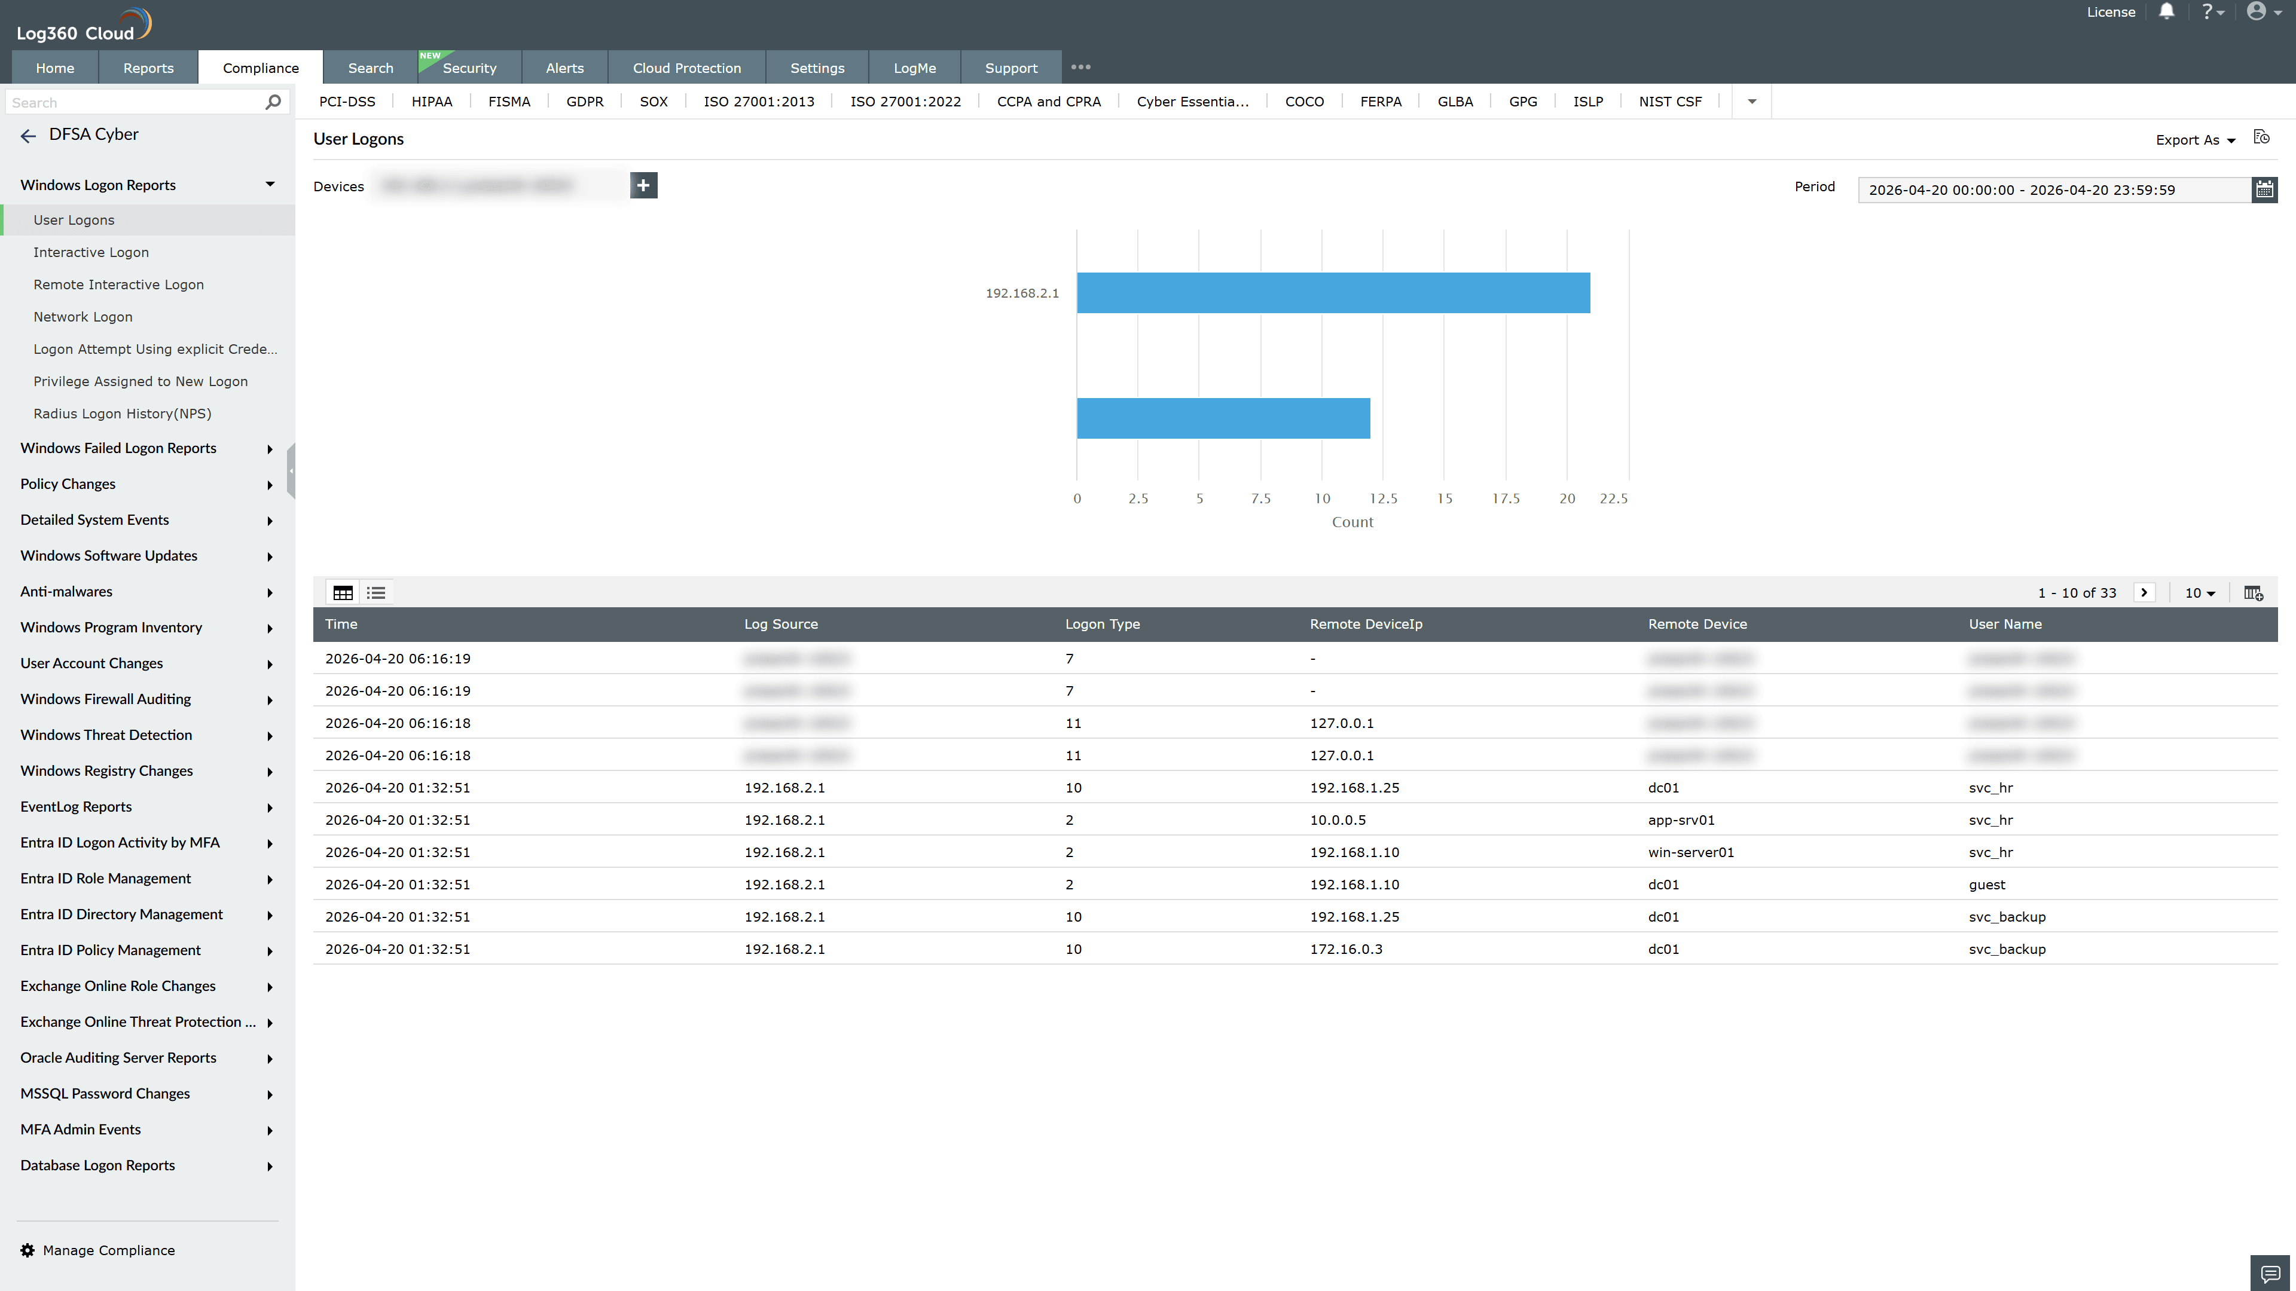
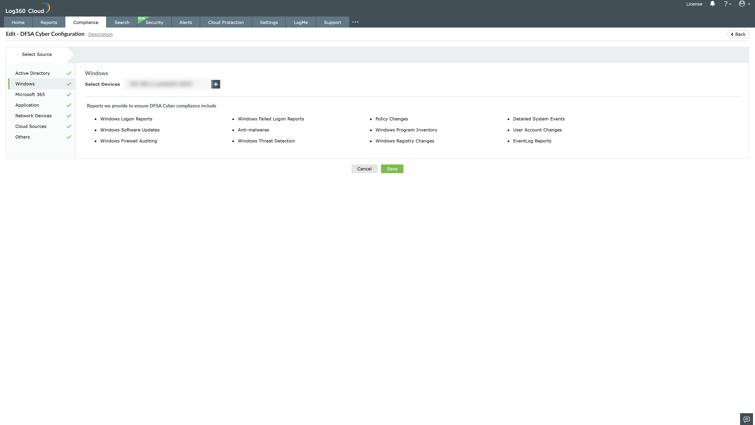

Valid Submission : Yes
Supported Editions : Free, Basic, Standard, Professional, MSSP
Help Document : https://www.manageengine.com/log-management/help/integrations/compliance-extensions.html
Help Video : Not provided
Tags : Log360, Compliance, Privacy monitoring, Data privacy, Regulatory compliance
Supported DCs : US, IN, JP, CA, AU, UK and EU
Privacy Policy:
Terms of Service:
Release Notes:
Predefined reports for the DFSA Cyber Risk Framework Compliance

